**PHax Track: An Immunization Database Management System and Tracking Android Mobile Application for Makati City**

1. **Brief Description**

The PHax Track will manage data and it will be connected to the centralized database. Each Filipino will be given an identification number that will be used for their accounts in the database. Each facility and healthcare professional will also be given a unique set of identification numbers which will serve as a security pass when adding information to the patient’s account. The android application will be used to track the immunization record and input data.

***Diagram 1: PHax Track Instruction Flow***

Healthcare professional

Input data Vaccine data

Show patient immunization record

Patient

Android Application

DBMS

DATABASE

Input Personal Information only

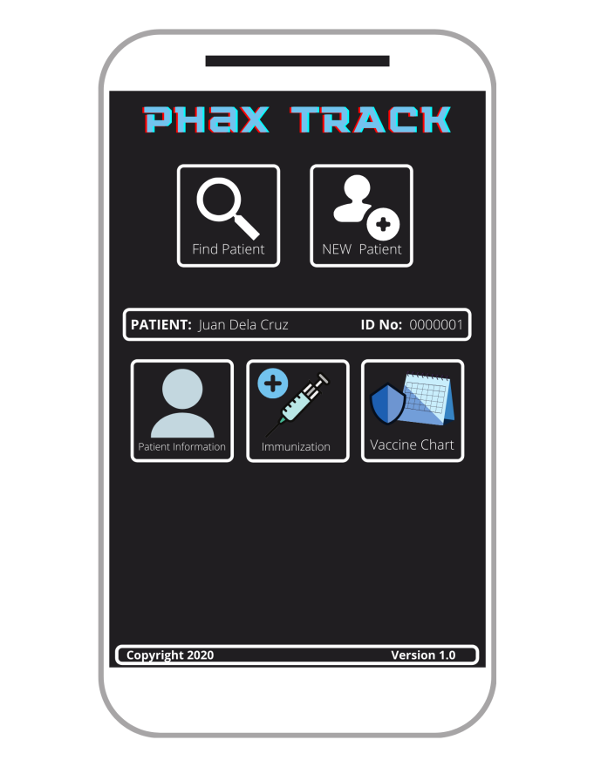***Diagram 2: Prototype Application Idea***

Existing Patient

Addition of New patient

**Data in the Database**

Name, Age, Birthday, Address

In Calendar Form, Patient’s immunization history): specific type of vaccine, institution who gave the vaccine)

Vaccine data to be given (input)

*Table 1: Patient Information (Example only)*

|  |  |  |  |  |
| --- | --- | --- | --- | --- |
| **Identification Number** | **Name of the Patient** | **Birthday** | **Age** | **Address** |
| P000001 |  |  |  |  |
| P000002 |  |  |  |  |
| P000003 |  |  |  |  |
| P000004 |  |  |  |  |
| P000005 |  |  |  |  |

*Table 2: List of Vaccines for Child and Adult Immunization according to Department of Health [DOH] (2020)*

|  |  |
| --- | --- |
| **Vaccine Identification Number** | **Name of the Vaccines** |
| V000001 | Bacillus Calmette-Guérin (BCG Vaccine) |
| V000002 | Hepatitis B Vaccine (HepB) |
| V000003 | Pentavalent Vaccine (DPT-Hep B-HIB) |
| V000004 | Oral Polio Vaccine (OPV) |
| V000005 | Inactivated Polio Vaccine (IPV) |
| V000006 | Pneumococcal Conjugate Vaccine (PCV) |
| V000007 | Measles Mumps Rubella (MMR Vaccine) |
| V000008 | RV (Rubella Vaccine) |
| V000009 | Measles Vaccine |
| V000010 | Tetanus- Diphtheria Vaccine (Td) |
| V000011 | Human Papillomavirus Vaccine |
| V000012 | Japanese Encephalitis Vaccine (JEV) |
| V000013 | Influenza Inactivated Vaccine (IIV) |
| V000014 | Influenza Live Attenuated Vaccine (LAIV) |
| V000015 | Varicella (VAR) |
| V000016 | Hepatitis A Vaccine (HepA) |
| V000017 | Haemophilus influenzae type b (Hib) |
| V000018 | Meningococcal B Vaccine (MenB) |
| V000019 | Meningococcal A,C,W,Y Vaccine (MenACWY) |
| V000020 | Herpes Zoster Live Vaccine |
| V000021 | Typhoid Vaccine |
| V000022 | Cholera Vaccine |
| V000023 | Diphtheria, Tetanus Toxoid and Pertussis Vaccine (DTP) |
| V000024 | Dengue Tetravalent Vaccine |
| V000025 | Rotavirus Vaccine |

*Table 3: List of Institution in Makati City that Offers Vaccination*

|  |  |
| --- | --- |
| **Institution Identification Number** | **Name of the Institution** |
| H000001 | Ospital ng Makati (OSMAK) |
| H000002 | Makati Medical Center |
| H000003 | St. Claire’s Medical Center |
| H000004 | SuperCare Medical Services, Inc. Makati |
| H000005 | Trinity Woman and Child Hospital |
| C000001 | Poblacion Health Center |
| C000002 | Olympia Health Center |
| C000003 | Pitogo Health Center |
| C000004 | Palanan Health Center |
| C000005 | Guadalupe Nuevo Health Center |
| C000006 | Bangkal Health Center |
| C000007 | Carmona Health Center |
| C000008 | San Isidro Health Center |
| C000009 | Rizal Health Center |
| C000010 | Kasilawan Health Center |
| C000011 | Tejeros Health Center |
| C000012 | Singkamas Health Center |
| C000013 | Pio del Pilar Puericulture Center |
| C000014 | La Paz Health Center |
| C000015 | San Antonio Health Center |
| C000016 | Cembo Health Center |
| C000017 | Pinagkaisahan Health Center |
| C000018 | South Cembo Health Center |
| C000019 | West Rembo Health Center |
| C000020 | Pio del Pilar Rural Health Unit |
| C000021 | Valenzuela Health Center |
| C000022 | Guadalupe Viejo Health Center |
| C000023 | Santa Cruz Health Center |
| L00001 | Marinus Vaccination Center |
| L00002 | Medtropolis Vaccine Clinic |
| L00003 | NEOMAT Medical Clinic & Rabies Vaccination Center |
| L00004 | Health Hub Clinic Makati |
| L00005 | Immunoboosters Clinic |
| L00006 | HealthFirst Clinic |
| L00007 | Halcyon Marine Healthcare Systems Inc. |
| L00008 | Affinity Vaccines |
| L00009 | Alejandro Doctors Medical Clinic |
| L00010 | FortMed Medical Clinic |
| L00011 | Brgy. Bel-Air Clinic |
| L00012 | Healthway |
| L00013 | Patient First Medical Center |
| L00014 | Brgy. San Lorenzo City of Makati Satellite Clinic |
| L00015 | Health Metrics Inc. |
| L00016 | Aventus Medical Care, Inc. Makati Clinic |

*\*Identification numbers that start with H are Hospitals*

*\*Identification numbers that start with L are Clinics*

*\*Identification numbers that start with C are Health Centers*

**Other References for Immunization Programs:**

*https://www.cdc.gov/vaccines/schedules/hcp/imz/adult-shell.html*

[*https://www.smartparenting.com.ph/health/your-kids-health/immunization-schedule-chart-philippines-2019-a00228-20190301-lfrm*](https://www.smartparenting.com.ph/health/your-kids-health/immunization-schedule-chart-philippines-2019-a00228-20190301-lfrm)

[*https://www.psmid.org/wp-content/uploads/2020/03/CPG-ADULT-IMMUNIZATION-2018.pdf*](https://www.psmid.org/wp-content/uploads/2020/03/CPG-ADULT-IMMUNIZATION-2018.pdf)

*https://www.philvaccine.org/education/adult-immunization-schedule*

*https://www.philvaccine.org/education/childhood-immunization-schedule*

[*https://www.makati.gov.ph/content/news/8522*](https://www.makati.gov.ph/content/news/8522)

*“The city’s 26 health centers give the following free vaccines to infants and children aged 0 to 59 months: Hep B (at birth); BCG (at birth); PENTA Hib (6 weeks, 10 weeks, and 14th week); OPV (6 weeks, 10 weeks, and 14th week); IPV (14th week); MR at 9 months; and MMR at 1 year old.”*

*https://www.makati.gov.ph/content/news/10742*